IW-15
YEAR 10 SCIENCE (ADJUSTED)
EARTH AND SPACE SCIENCE
TEST 1

NAME: MARK: 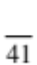

The universe contains features including galaxies, stars and solar systems and the Big Bang theory can be used to explain the origin of the universe.

1. Patterns of stars in the night sky are called:
QUESTION | ANSWER
1
2
3
4
5
6
7
8
9
10
11
12
13
14
15
(a) asteroids.
(b) galaxies.
(c) nebulae.
(d) constellations.

2. A light year is defined as:

(a) the distance light travels from the closest star.
(b) the distance from Alpha Centauri to the sun.
(c) the distance of the Earth from the sun.
(d) the distance light travels in a year.

3. The main fuel of stars is:

(a) hydrogen.
(b) helium.
(c) carbon.
(d) gold.

4. Clouds of gas and dust that form spectacular images are:

(a) stars.
(b) nebulae.
(c) planets.
(d) suns.

5. When a star the size of our Sun begins to run out of fuel, it transforms
and swells in size until it becomes a:

(a) white dwarf.
(b) red giant.
(c) red dwarf.
(d) white giant.

6. Which one of the following gives the correct order of size from smallest to largest?

(a) Universe, planet, galaxy, solar system.
(b) Planet, solar system, galaxy, universe.
(c) Planet, galaxy, solar system, universe.
(d) Galaxy, universe, planet, solar system.
7. A galaxy is a group of many billions of stars held together by:

(a) gravitational forces.
(b) electrical forces.
(c) magnetic forces.
(d) quasars.

8. The Milky Way (where our solar system is found) is most accurately described as a:

(a) planet.
(b) universe.
(c) solar system.
(d) galaxy.

9. Many scientists expect that Man will travel to other planets in the solar system within the next 100 years. They do not think, however, that Man will travel to planets of other stars in the universe in the next 100 years.

The main reason that trips to planets of other stars in this period are unlikely is that scientists:

(a) don’t know which stars have planets.
(b) fear that the planets may have strange life forms, which could harm the astronauts.
(c) doubt that there are any other stars that have planets.
(d) realise that such trips would take too long because the distances are so great.

10. In the sun, hydrogen is transformed into:

(a) carbon dioxide.
(b) helium.
(c) oxygen.
(d) water.

11. The ‘big bang’ theory is a possible explanation of:

(a) the birth of a star.
(b) the expansion of the universe.
(c) the collapse of the universe.
(d) the formation of the solar system.

12. Which statement is the best description of the universe?

(a) A collection of stars, separated by absolutely empty space.
(b) A collection of galaxies, nebulae and stars.
(c) A collection of solar systems separated by empty space.
(d) The Milky Way galaxy, made of stars and planets.

13. The age of the universe is believed by cosmologists to be closest to:

(a) 15 thousand years.
(b) 15 million years.
(c) 15 billion years.
(d) 15 trillion years.

14. Compared to other stars in the universe, the mass of the Sun could be best described as:

(a) huge.
(b) average.
(c) small.
(d) similar.

15. The colour of a star is most directly related to its:

(a) age.
(b) location.
(c) surface temperature.
(d) volume.

Short Answer Write the answer to the questions in the spaces provided.

1. Use the words listed below to complete the following sentences.

protostar | billion | Milky Way | giants
constellations | space | nebulae | expansion
fusion

Groups of stars form patterns that are called .

Our solar system is part of a large galaxy called the .

Clouds of dust and gas in interstellar space are called .

According to the Big Bang Theory, the universe is about 13.7 years old.

The first stage of the Big Bang involved the formation of time and . Space

then underwent rapid .

Stars are formed when gravity causes gas and dust to come together and heat up. Eventually a

is formed and then finally a star.

Stars like our sun evolve into red before they explode.

Stars generate their energy by nuclear in which hydrogen changes to helium.

(9)

2. Choose the correct definition for the term in the first column of the table below. Write the correct letter in the second column.

TERM | CORRECT LETTER | DEFINITION
Black dwarf |  | A: Pattern formed by a group of stars.
Nova |  | B: Formed by the expansion of a star about the size of  our Sun.
Red giant |  | C: Remains of the death of a massive star.
Black hole |  | D: Small, dead star that emits no light.
Constellation |  | E: Final stage in the development of a star.
Protostar |  | F: Explosion of the outer layers of an average-size star.

(6)

3. The diagram below shows the spectra (black lines) seen on the light coming from distant galaxies.
Look at the "double lines" shown here. This shows the lines as seen in our laboratory.

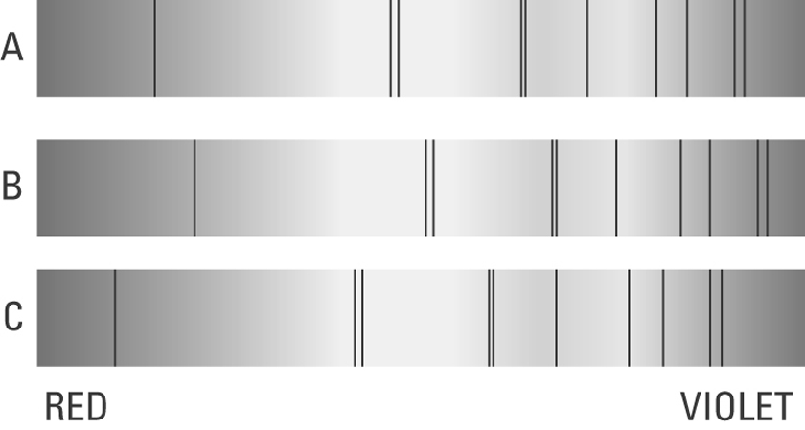

Look at B and C above and where the double lines have moved.

(a) Circle the lines that have been "red-shifted". (1)

(b) Does "red-shift" mean the galaxy is moving towards us? Circle your answer.

YES NO (1)

4. Use the words below to complete the two pathways listed below.

white dwarf | black dwarf | nova | supernova | red giant
black hole | red supergiant

(a) Our Sun has an interesting pathway until its ultimate "death". Complete the labelled flow diagram to show the stages involved in this pathway.
(4)

Sun    

(b) Below is a pathway for stars much larger than our Sun. Draw a labelled flow diagram for this
pathway.
(3)

Huge Star   

5. Give two characteristics or facts you know about a black hole?
(2)

•

•

